Quick Details
- Place of Origin: Guangdong, China (Mainland)
- Brand Name: REBECCA, rebecca
- Model Number: R09015W1
- Material: Plastic
- Color: Silver
- Light Source: Fluorescent
- Style: Modern
- Description: energy saving instant flicker free start wall lamp
- style: modern
- Feature: self mold/special mold
- Size: L241 x H258 x P58mm
- Shape: Circle
- Certification: CE, UL ,SAA
- MOQ: 100pcs
- Metal Finish: matt silver/white
- Color temperaturer: warm white/cold white

Packaging & Delivery
Packaging Details | Colorful box L26.5 x W30 x H7cm  9600pcs for 40GP container  4600pcs for 20GP container
Delivery Time | 25-30days
Modern simple design matt silver circle glass wall lamp with self mold
1.Lampsize:L241 x H258 x P58mm
2.Finish: Silver Grey
3.1 x 22W 80% energy saving
4.Colors filters , green/blue/yellow 3colors for choosing
5.metal base lamp
6.The picture in other different color filter:

7.Packaging :1piece to one colorful box,10 boxes to 1 carton
colorful boxsize :L26.5 x W30 x H7cm
carton size : L55*W38*H32.5cm
Certification:CE
Remark
REMARK:

Delivery time: 20-30days,it may also will be vary based on different design and quantity.
Payment term: T/T or L/C at sight. But we also can accept to pay by West Union.

Warranty: We keep 1 year warranty to all the surface of our products and to the electrical parts and other aspect of our products, we keep 3 years warranty.
Our company,Rebecca lighting was a specialized lighting manufacturer with over 10 years exporting experience. All our products are CE, UL, SASO approved. Our factory have passed the factory audit by SGS, V-Trust as well. The space of our factory with our big showroom has reached 5200 square meters, each customer who visit to our factory can find their favorite lamps in our big showroom which displays thousands of lights.

Our factory address:Xinmao industrial Area,HengLan Town,ZhongShan city,GuangDong,China. TEL:+86-760-87682576 whatsapp:+8613925343170 Skype:rebeccalightsales3mo
our Service
We provide this wall lighting fixture with high quality and good service. OEM designs are also welcome.
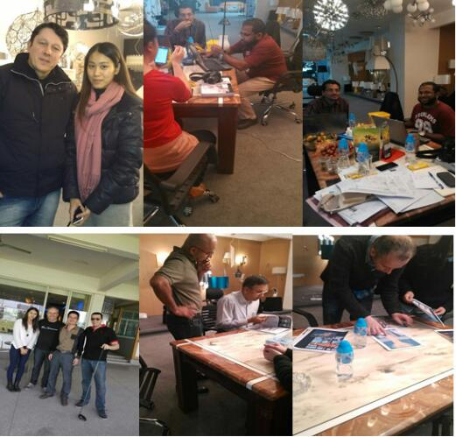
company information
Zhongshan Guzhen Rebecca Lighting Factory focus on manufacturing high class level interior decorative lamps for many years. Our product line is ranging from hotel lamps, European style lamps, modern and classic designs. Over thousands product designs help you to find your ideal item easily.

By rich experience in lighting field, and doing exporting business for more than 10 years, we can give you the best lighting solution for your hotels, departments, residential houses, villas and resorts. We supply reliable post-sales service, competitive price and good quality products.
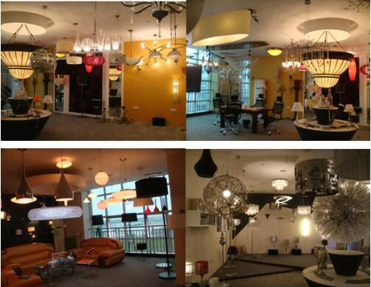
Packing &shipping
Packing Details :
1.Lamp frame and beads SKD (semi Knock Down) packing with Styrofoam inside.
2.Five layer standard brown carton and wooden packed outside.
3.Every package have English installation manuel and pictures.
4.The package also can according to your request.
About the of shipping :
you can choose express delivery ,airfreight , or seafreight .All depend on the quantity of order.
1, express delivery--FEDEX, DHL, TNT, UPS,
For the small quantity, such as one or two, or ten pieces, you can choose express delivery that will be faster and safer, and you can receive the goods in your house,except the remote area.
we have some good Express partners.They may give more discount on the air freight fee which will much lower than your local account .
2, Airfreight:
Also for the small quantity. It is more economic than express delivery but you need to make customs clearance in your local city for yourself.
3, Seafreight:
As the most economic means of transportation, seafreight is suitable for bulk goods and full contianer cargo, but it will take much more times to arrive at your destination.
With so many years of experience in exporting table lamp, we can give you the best service such as booking container,making custom clearance etc.
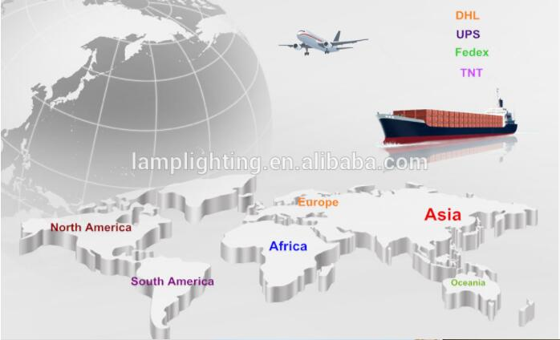Projects:
Mandalayhill resort in Myanmar
Longbeach in Maldives
Dubai hotel in Oman
Golden Pine Hotel in Philippines
Pan Asia restaurant in India
Hilton Jaipur India
Amra Palace International Hotel in Jordan
Lords Beach Hotel Dubai
Ibis Hotel Dubai
Intercontinental Hotel Mauritius
Pearl Qatar
Marinascape development which designed by Magus
Radisson Hotel which designed by IMA interiors Singapore
AT AIN ROTANA Hotel which designed by IDEA ART
Al Manzil Hotel which designed by Wilson associates Singapore
Burjuman Rotana apartments which designed by Wilson associates Singapore
The palace Hotel which designed by Wilson associates Singapore
Kempinski Hotel mall of the emirates by Wilson associates Singapore
The address Dubai designed by Wilson associates Singapore
Dusit international Hotel located Dubai
RAMADA Hotel located DOHA

